# Risk Management Strategy

**RMS Diagram:**

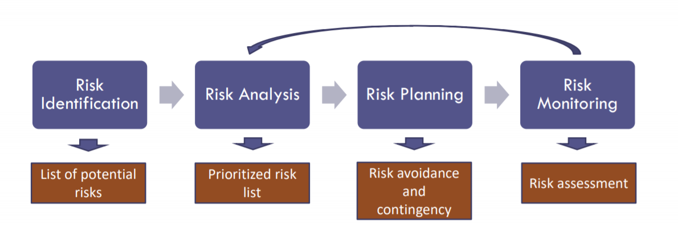

Risk management is one of the most import job duties of a project manager. The process can be divided into four part: risk identification, risk analysis, risk planning, and risk monitoring;

* Risk identification is the process of identifying a list of potential risks that may occur during the project.
* Risk Analysis is the process to analyse the list of risk identified and prioritize the risks that need to be addressed base on its impact and probability.
* Risk Planning is the process to plan the reaction to a risk occurrence. This step lays out the plans on how to handle and react to an occurring risk. It is very important because a timely and correct reaction can help to reduce the risk impact to the minimum when risk occurs.
* Risk monitoring is a continuous action that oversee the project in case of risks occur. A good risk monitoring process help the group respond to a risk in a timely matter.

**Project Risk:**

|  |  |  |  |
| --- | --- | --- | --- |
| Risk | Probability | Impact | Mitigation Method |
| Loss of talents and core staffs / Team Reconstruction | low | High | Maintaining a competitive compensation plans and periodic check in with employees |

**Product Risk:**

|  |  |  |  |
| --- | --- | --- | --- |
| Risk | Probability | Impact | Mitigation Method |
| Application or system failure or Corruption | Medium | High | Maintaining constant backup of the system and database;  Continuously monitor online application and its resource utilization rate;  Have an on-call team in place to immediately react to issues 24/7; |
| Outdated technologies and skill sets | Low | Medium | Implementing education program to help staffs maintain up to date skill sets;  Constant research on new technologies and push updates; |
| Data securities and privacy issues | Medium | High | Maintain up to date cybersecurity technologies and maintain sensitive dates in secure environments |

**Business Risk:**

|  |  |  |  |
| --- | --- | --- | --- |
| Risk | Probability | Impact | Mitigation Method |
| Misleading Product Information | high | Medium | Implement policies that promote honesty and punish fraudulent actions; |
| Shipment and transportation Issues | Medium | Low | Establish contract with third party shipment agencies and custom clearance agencies;  Offer additional insurance option for buyers; |
| Fraudulent Seller | Low | Low | Implement policy that payments to sellers are distributed in instalments over a reasonable period;  Actively Investigate claimed fraudulent actions and permanently ban dishonest seller; |

We will use the following as our main strategies during the project development:

* **Risk Avoidance strategy:**  we want to avoid risk before it occurs. We establish and implement methods and policies that can help us avoid risks before occurrences. For example, we understand that product shipments require significant resources and we are unable to step into that industry. We want to avoid the risk of lost/damaged packages and custom clearance issues. Thus, we partner with third parties to avoid those risks.
* **Risk Control / Mitigation:** in situation where we cannot avoid the probably of risk occurrences, we establish policies to timely control the impact to the minimum. For instance, we understand that we cannot avoid dishonest sellers completely. We set policies to minimize the negative impact of dishonest sellers.
* **Accept Risk:** in case of risk that cannot be avoid, we accept such risk and budget for its occurrences. For example, we accept the risk of outdated technologies. We budget for technology conferences and periodic training for our development teams.
* **Transfer Risk:** we partner with third parties to transfer some of the risks. For example, we outsource shipment to shipping companies and custom clearance duty to custom clearance agencies. In case of lost/damaged packages or custom clearance problems, we have the third party liable.